1.What is protocol?

Sometimes referred to as an access method, a **protocol** is a standard used to define a method of exchanging data over a computer network such as [local area network](http://www.computerhope.com/jargon/l/lan.htm), [Internet](http://www.computerhope.com/jargon/i/internet.htm), [Intranet](http://www.computerhope.com/jargon/i/intranet.htm), etc. Each protocol has its own method of how data is formatted when sent and what to do with it once received, how that data is compressed or how to check for errors in data.

One of the most common and known protocols is [HTTP](http://www.computerhope.com/jargon/h/http.htm)(HyperText Transfer Protocol), which is a protocol used to transmit data over the world wide web (Internet).

2.What is network?

 A **network** is a collection of computers, servers, mainframes, network devices, peripherals, or other devices connected to one another to allow the sharing of data. A excellent example of a network is the [Internet](http://www.computerhope.com/jargon/i/internet.htm), which connects millions of people all over the world.

3.Types of netwotk?

• **[local-area networks (LANs)](http://www.webopedia.com/TERM/L/local_area_network_LAN.html):** The computers are geographically close together (that is, in the same building).

• **[wide-area networks (WANs)](http://www.webopedia.com/TERM/W/wide_area_network_WAN.html):** The computers are farther apart and are connected by telephone lines or radio waves.

• **[campus-area networks (CANs)](http://www.webopedia.com/TERM/C/CAN.html):** The computers are within a limited geographic area, such as a campus or military base.

• **[metropolitan-area networks MANs)](http://www.webopedia.com/TERM/M/MAN.html):** A data network designed for a town or city.

• **[home-area networks (HANs)](http://www.webopedia.com/TERM/H/HAN.html):** A network contained within a user's home that connects a person's digital devices.

4.Network topologies and types of networks?

The term [network topology](http://www.computerhope.com/jargon/t/topology.htm) describes the relationship of connected devices in terms of a geometric graph. Devices are represented as vertices, and their connections are represented as edges on the graph. It describes how many connections each device has, in what order, and it what sort of hierarchy.

Typical network configurations include the [bus topology](http://www.computerhope.com/jargon/b/bustopol.htm), [mesh topology](http://www.computerhope.com/jargon/m/mesh.htm), [ring topology](http://www.computerhope.com/jargon/r/ringtopo.htm), [star topology](http://www.computerhope.com/jargon/s/startopo.htm), [tree topology](http://www.computerhope.com/jargon/t/treetopo.htm) and [hybrid topology](http://www.computerhope.com/jargon/h/hybrtopo.htm).

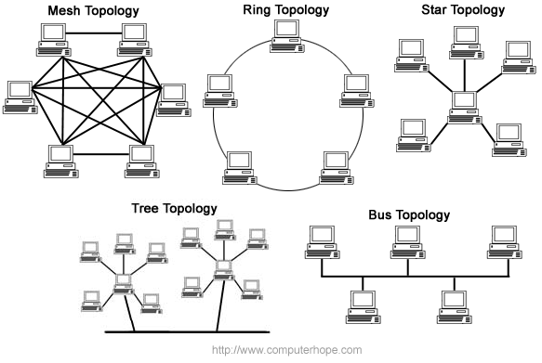

Most [home networks](http://www.computerhope.com/jargon/h/homenetw.htm) are configured in a tree topology that is connected to the Internet. Corporate networks often use tree topologies, but they typically incorporate star topologies, and an [Intranet](http://www.computerhope.com/jargon/i/intranet.htm) which is isolated from the Internet.

5.server?

In a technical sense, a **server** is an [instance](http://www.computerhope.com/jargon/i/instance.htm) of a computer program that accepts and responds to requests made by another program, known as a [client](http://www.computerhope.com/jargon/c/client.htm). Less formally, any device that runs server software could be considered a server as well. Servers are used to manage [network](http://www.computerhope.com/jargon/n/network.htm) resources. For example, a user may setup a server to control access to a network, send/receive e-mail, manage print jobs, or host a website.

6. server software?

A server operating system, also called a server OS, is an operating system specifically designed to run on [servers](http://www.webopedia.com/TERM/S/server.html), which are specialized computers that operate within a [client/server architecture](http://www.webopedia.com/TERM/C/client_server_architecture.html) to serve the requests of client computers on the network.

7. ip address ?

 Short for **Internet Protocol address**, an **IP** or **IP address** is a number (example shown right) used to indicate the location of a computer or other device on a network using [TCP/IP](http://www.computerhope.com/jargon/t/tcpip.htm). These addresses are similar to those of your house; they allow data to reach the appropriate destination on a network and the Internet.

For more details.refer this link

<http://www.computerhope.com/jargon/i/ip.htm>

8.tcp/ip?

Short for **Transmission Control Protocol/Internet Protocol**, **TCP/IP** is a set of rules ([protocols](http://www.computerhope.com/jargon/p/protocol.htm)) governing communications among all computers on the Internet. More specifically, TCP/IP dictates how information should be packaged (turned into bundles of information called [packets](http://www.computerhope.com/jargon/p/packet.htm)), sent, and received, as well as how to get to its destination. TCP/IP was developed in [1978](http://www.computerhope.com/history/1978.htm) and driven by [Bob Kahn](http://www.computerhope.com/people/bob_kahn.htm) and [Vint Cerf](http://www.computerhope.com/people/vint_cerf.htm).

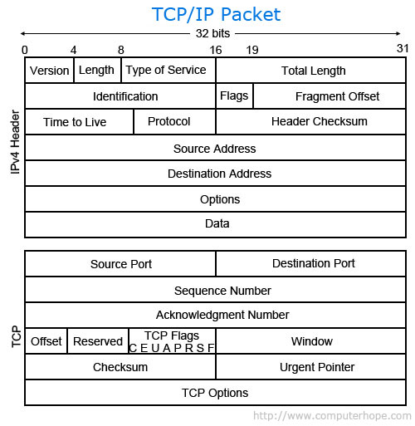

## How does TCP/IP work?

As the name implies, TCP/IP is a combination of two separate protocols: Transmission Control Protocol ([TCP](http://www.computerhope.com/jargon/t/tcp.htm)) and Internet Protocol ([IP](http://www.computerhope.com/jargon/i/ip.htm)). The Internet Protocol standard dictates the logistics of packets sent out over networks; it tells packets where to go and how to get there. IP has a method that lets any computer on the Internet forward a packet to another computer that is one or more intervals closer to the packet's recipient. You can think of it like workers in a line passing boulders from a quarry to a mining cart.

The Transmission Control Protocol is responsible for ensuring the reliable transmission of data across Internet-connected networks. TCP checks packets for errors and submits requests for re-transmissions if any are found.

## Three of the most common TCP/IP protocols

* **HTTP** - Used between a web [client](http://www.computerhope.com/jargon/c/client.htm) and a web [server](http://www.computerhope.com/jargon/s/server.htm), for *non-secure* data transmissions. A web client (i.e. Internet browser on a computer) sends a request to a web server to view a web page. The web server receives that request and sends the web page information back to the web client.
* **HTTPS** - Used between a web client and a web server, for *secure* data transmissions. Often used for sending credit card transaction data or other private data from a web client (i.e. Internet browser on a computer) to a web server.
* **FTP** - Used between two or more computers. One computer sends data to or receives data from another computer directly.

## Domain names and TCP/IP addresses

The TCP/IP address for a website or web server is typically not easy to remember. To remedy this issue, a [domain name](http://www.computerhope.com/jargon/d/domain.htm) is used instead. For example, **45.79.151.23** is the IP address for the Computer Hope website and **computerhope.com** is the domain name. Using this method, instead of a set of numbers, makes it much easier for users to remember Computer Hope's [web address](http://www.computerhope.com/jargon/a/address.htm).

9.packet?

A term first coined by [Donald Davies](http://www.computerhope.com/people/donald_davies.htm) in [1965](http://www.computerhope.com/history/1965.htm), a **packet** is a segment of [data](http://www.computerhope.com/jargon/d/data.htm) sent from one computer or device to another over a [network](http://www.computerhope.com/jargon/n/network.htm). A packet contains the [source](http://www.computerhope.com/jargon/s/source.htm), [destination](http://www.computerhope.com/jargon/d/destinat.htm), size, type, data, and other useful information that helps packet get to its destination and read. Below is a breakdown of a TCP packet.

# 10.**Firewall**

**firewall** is a [software](http://www.computerhope.com/jargon/s/software.htm) utility or [hardware](http://www.computerhope.com/jargon/h/hardware.htm) device that limits outside [network](http://www.computerhope.com/jargon/n/network.htm) [access](http://www.computerhope.com/jargon/a/access.htm) to a computer or local network by blocking or restricting network [ports](http://www.computerhope.com/jargon/p/port.htm).

Firewalls are a great step for helping prevent un-authorized access to a company or home network. The picture is an example of a hardware firewall, the [ZyXEL](http://www.computerhope.com/comp/zyxel.htm) ZyWALL a Unified Security Gateway with a Firewall and other security features.

## Hardware firewalls

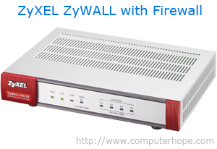**Hardware firewalls** are also found in most network [routers](http://www.computerhope.com/jargon/r/router.htm)and can be configured and setup through the [router setup](http://www.computerhope.com/issues/ch001062.htm). **Software firewalls** are designed to protect the computer they are installed onto by blocking any unrestricted programs from sending and receiving information from the network or Internet. A good example of a software Firewall is the Windows Firewall that is included with Microsoft Windows.

11.router

analyze and move incoming [packets](http://www.computerhope.com/jargon/p/packet.htm) to another [network](http://www.computerhope.com/jargon/n/network.htm). It may also be used to convert the packets to another network interface, [drop](http://www.computerhope.com/jargon/d/drop.htm) them, and perform other actions relating to a network. The picture shows the Linksys BEFSR11 **wirelessrouter** and is what many home routers resemble.

A **router** has a lot more capabilities than other network devices, such as a [hub](http://www.computerhope.com/jargon/h/hub.htm) or a [switch](http://www.computerhope.com/jargon/s/switch.htm) that are only able to perform basic network functions. For example, a hub is often used to transfer data between computers or network devices, but does not analyze or do anything with the data it is transferring. By contrast, routers can analyze the data being sent over a network, change how it is packaged, and send it to another network or over a different network. For example, routers are commonly used in home networks to share a single Internet connection between multiple computers.



12.wireless?

The word wireless is dictionary defined as "having no wires". In [networking](http://www.webopedia.com/TERM/N/networking.html) terminology, wireless is the term used to describe any [computer](http://www.webopedia.com/TERM/C/computer.html) network where there is no physical wired connection between sender and receiver, but rather the network is connected by radio waves and/or microwaves to maintain communications. Wireless networking utilizes specific equipment such as [NIC](http://www.webopedia.com/TERM/N/network_interface_card_NIC.html)s, [AP](http://www.webopedia.com/TERM/A/AP.html)s and [routers](http://www.webopedia.com/TERM/R/router.html) in place of wires ([copper](http://www.webopedia.com/TERM/C/CDDI.html) or [optical fiber](http://www.webopedia.com/TERM/F/fiber_optics.html)) for connectivity.

13.ethernet:

**Ethernet**: This is the backbone of your network. It consists of the cabling (called "cat 5" cable) and is typically able to transfer data at a rate of 100mb/s (read more about bandwidth). What is not shown here are the hubs and switches that are used to connect computers and other devices together.

14. internet?

A means of connecting a computer to any other computer anywhere in the world via dedicated routers and servers. When two computers are connected over the Internet, they can send and receive all kinds of information such as text, graphics, voice, video, and computer program.  
  
The Internet is generally defined asa global[*network*](http://www.webopedia.com/TERM/N/network.htm)connecting millions of[*computers*](http://www.webopedia.com/TERM/C/computer.htm). More than 190 countries are linked into exchanges of [data](http://www.webopedia.com/TERM/D/data.htm), news and opinions.

15. client?

 A **client** is a [computer](http://www.computerhope.com/jargon/c/computer.htm) that retrieves information from or uses resources provided by the [server](http://www.computerhope.com/jargon/s/server.htm) or main computer. Many corporate networks are comprised of a client computer at each of the employees' desks. Each client connects to a central server or [mainframe](http://www.computerhope.com/jargon/m/mainfram.htm) that allows processing to be done on the **client side** instead of the server side and reduces the processing requirements of the server.

16.www?

The World Wide Web (abbreviated **WWW** or the Web) **is** an information space where documents and other web resources are identified by Uniform Resource Locators (URLs), interlinked by hypertext links, and can be accessed via the Internet. English scientist Tim Berners-Lee invented the World Wide Web in 1989.

17. encoding and decoding?

In computers, encoding is the process of putting a sequence of [character](http://searchcio-midmarket.techtarget.com/definition/character)s (letters, numbers, punctuation, and certain symbols) into a specialized format for efficient transmission or storage. Decoding is the opposite process -- the conversion of an encoded format back into the original sequence of characters. Encoding and decoding are used in data communications, networking, and storage. The term is especially applicable to radio ([wireless](http://searchmobilecomputing.techtarget.com/definition/wireless)) communications systems.